|  |  |  |  |  |  |  |  |  |  |  |  |  |  |  |
| --- | --- | --- | --- | --- | --- | --- | --- | --- | --- | --- | --- | --- | --- | --- |
| **DIT UNIVERSITY DEHRADUN**   |  |  | | --- | --- | | **M.TECH (CSE)** | **MID TERM EXAMINATION, ODD SEM 2023-24 (SEM I)** | | | | | | | | | | | | | |
| **Roll No.** |  |  |  |  |  |  |  |  |  |  |  |  |
| **Subject Name: Artificial Intelligence and Knowledge Representation** | | | | | | | | | | | | |

|  |  |
| --- | --- |
| **Time: 2 Hours** | **Total Marks: 50** |
| **Note: All questions are compulsory. No student is allowed to leave the examination hall before the completion of the exam.**  **______________________________________________________________________________________________________**   |  |  |  | | --- | --- | --- | | **Q.1)** | **Attempt all Parts :** | | |  | **(a)** | Explain depth-limited search algorithm with a suitable example. | |  | **(b)** | Solve the Cryptarithmetic problem shown below where every character/letter must have a unique and distinct value. | |  | **(c)** | List two advantages of DFS. | |  | **(d)** | Consider the graph given in Figure 1, apply Uniform Cost Search to traverse from Sibiu to Bucharest. | |  |  | **[4 x 2.5= 10]** | | **Q.2)** | **Attempt all Parts :** | | |  | **(a)** | Identify variables, domains and constraints in the given Map Coloring problem (shown in Figure 2) (Coloring different regions of map ensuring no adjacent regions have the same color where colors are Red, Green and Blue) using the concept of constraint satisfaction problem. | |  | **(b)** | Summarize PEAS description/representation for the Hospital Management System (agent). | |  | **(c)** | Consider the given search tree in Figure 3, apply BFS and DFS algorithms to traverse it where 40 is the initial state | |  | **(d)** | Differentiate between informed search and uninformed search. | |  |  | **[4 x 2.5= 10]** | | **Q.3)** | **Attempt any Two Parts :** | | |  | **(a)** | Apply Minimax strategy on the Game Tree given in Figure 4. Find the optimal strategy for MAX assuming an infallible MIN opponent. Assumption: Both players play optimally. Explain step by step. | |  | **(b)** | Explain the following terms with suitable diagrams:   1. Learning Agent 2. Goal Based Agent | |  | **(c)** | Define bidirectional search algorithm. List its two advantages and two disadvantages. | |  |  | **[2 x 5= 10]** | | **Q.4)** | **Attempt any Two Parts :** | | |  | **(a)** | Define intelligent agent and discuss its various components. | |  | **(b)** | Consider the map of Romania with cities and distance between them as shown in Figure 5, apply A* algorithm to find route from Arad to Bucharest. Explain step by step. Note: Straight line distance to Bucharest represents H(n) value. | |  | **(c)** | Describe simple reflex agent with suitable diagram. | |  |  | **[2 x 5= 10]** | | **Q.5)** | **Attempt any Two Parts :** | | |  | **(a)** | Consider the map of Romania with cities and distance between them as shown in Figure 5, apply greedy best-first search algorithm to find the shortest route from Arad to Bucharest. Explain step by step. Note: Straight line distance to Bucharest represents H(n) value. | |  | **(b)** | Explain the following environments with suitable example of each:   1. Fully observable and partially observable 2. Episodic and sequential | |  | **(c)** | Define artificial intelligence and explain its any four applications. | |  |  | **[2 x 5= 10]** | | **-----END OF PAPER ----** | | | | |

**FIGURE DETAILS**

|  |  |
| --- | --- |
|  | **australia** |
| **Figure 1** | **Figure 2** |
|  |  |
| **Figure 3** | **Figure 4** |

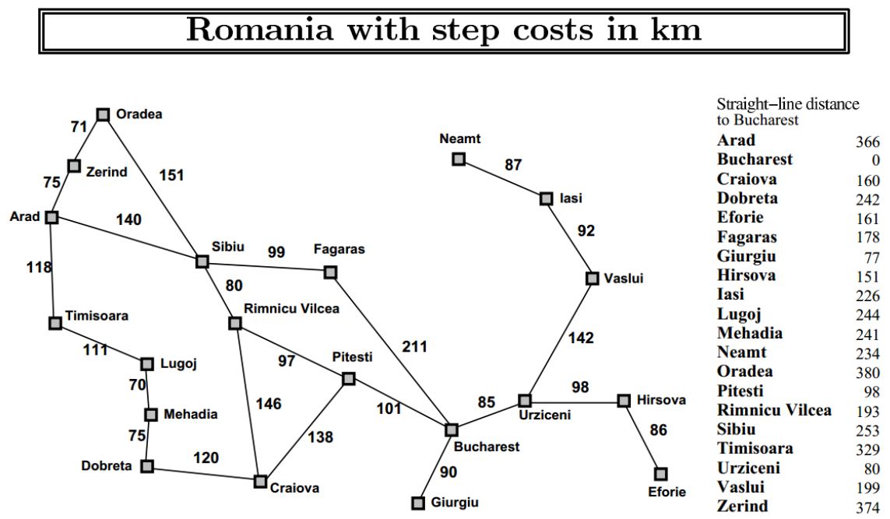

**Figure 5**